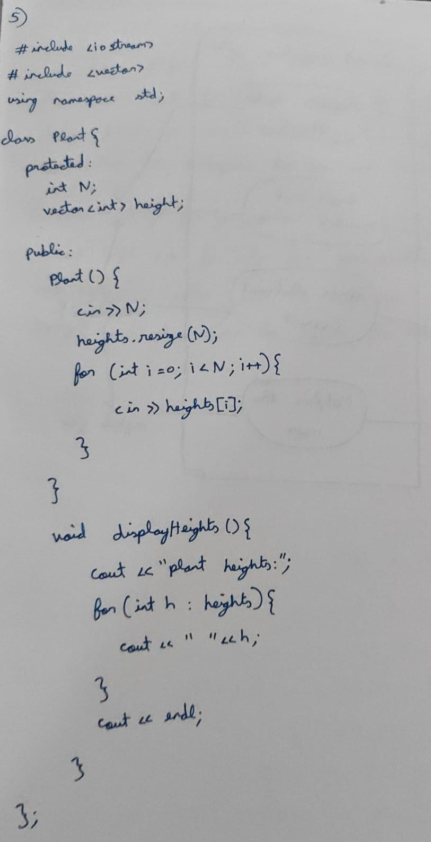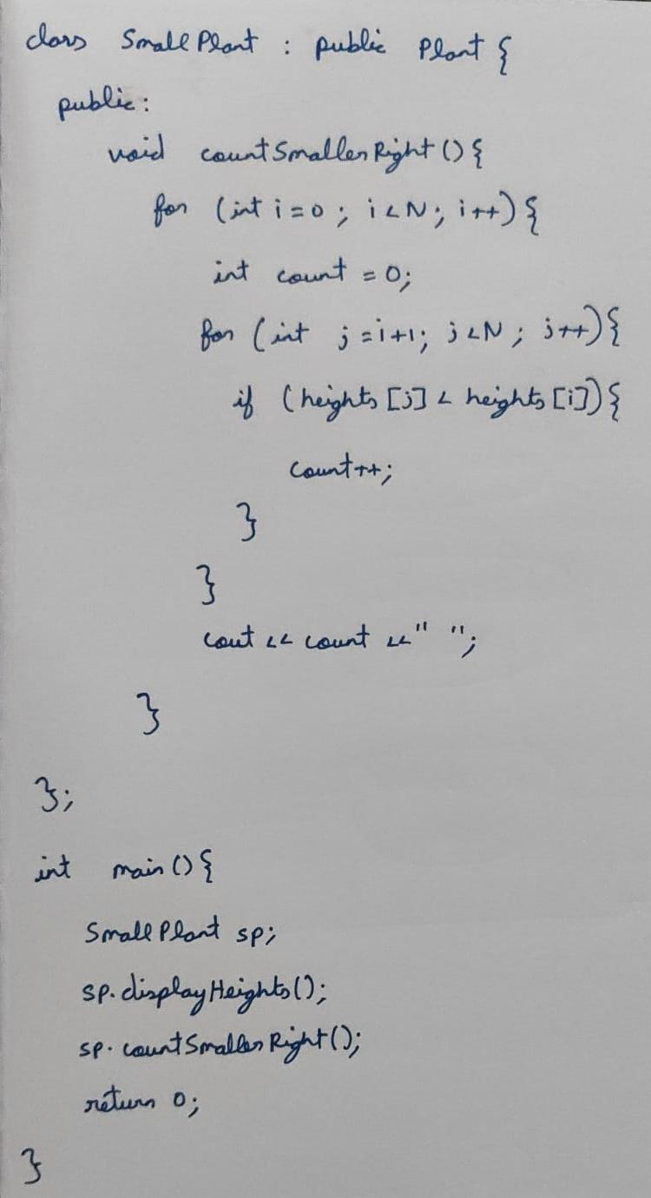Results and analysis

Theory and Discussion=>
Diagram Description –
The diagram provided by the student illustrates a Smart Irrigation System and its components. Below is a detailed description of the diagram, highlighting the points, text, shapes, arrows, and other elements, so that the diagram can be recreated based on this description:
Overall Structure
- The diagram is drawn on a white background with blue ink.
- It is organized into a central rectangular box labeled "Smart irrigation system", which contains several circular shapes representing different functions.
- Arrows are used to show the flow of information and interactions between components.
Central Box: Smart Irrigation System
- Shape: A large rectangular box labeled "Smart irrigation system" at the top center.
- Functions Inside the Box:
  - Four circular shapes are placed inside the box, each representing a specific function of the system. These are:
    - Measures Water Level
    - Reads Soil Moisture Value
    - Sends Electrical Current
    - Notifies the User
  - Each circular shape is connected to other components outside the box using arrows.
Components Outside the Box
- Ultrasonic Ranger
  - Shape: A small label on the left side of the diagram.
  - Connection: An arrow points from the Ultrasonic Ranger to the "Measures Water Level" function inside the central box.
  - Purpose: The Ultrasonic Ranger is used to measure the water level.
- Moisture Sensors
  - Shape: A label on the left side, below the Ultrasonic Ranger.
  - Connection: An arrow points from the Moisture Sensors to the "Reads Soil Moisture Value" function inside the central box.
  - Purpose: The Moisture Sensors are used to read the soil moisture value.
- Solenoid Valves
  - Shape: A label on the left side, below the Moisture Sensors.
  - Connection: An arrow points from the "Sends Electrical Current" function inside the central box to the Solenoid Valves.
  - Purpose: The Solenoid Valves receive electrical current to control water flow.
- Raspberry Pi
  - Shape: A label on the right side of the diagram.
  - Connection:
    - Arrows point from the "Measures Water Level" and "Reads Soil Moisture Value" functions to the Raspberry Pi.
    - An arrow points from the Raspberry Pi to the "Sends Electrical Current" function.
  - Purpose: The Raspberry Pi processes data from sensors and controls the system.
- Mobile App
  - Shape: A label on the right side, below the Raspberry Pi.
  - Connection: An arrow points from the Raspberry Pi to the Mobile App.
  - Purpose: The Mobile App is used to notify the user about system status or alerts.
- Users
  - Shape: A label on the left side, below the Solenoid Valves.
  - Connection: An arrow points from the "Notifies the User" function inside the central box to the Users.
  - Purpose: The system notifies the user through the Mobile App.
Arrows and Flow
- Arrows are used to indicate the direction of data flow or control signals:
  - From the Ultrasonic Ranger to "Measures Water Level".
  - From the Moisture Sensors to "Reads Soil Moisture Value".
  - From "Measures Water Level" and "Reads Soil Moisture Value" to the Raspberry Pi.
  - From the Raspberry Pi to "Sends Electrical Current".
  - From the Raspberry Pi to the Mobile App.
  - From the "Notifies the User" function to the Users.
Text and Labels
- All text is written in blue ink.
- Labels are clear and concise, such as "Ultrasonic Ranger", "Moisture Sensors", "Solenoid Valves", "Raspberry Pi", and "Mobile App".
- Function labels inside the central box are also clear, such as "Measures Water Level", "Reads Soil Moisture Value", "Sends Electrical Current", and "Notifies the User".
Recreation Instructions
To recreate this diagram:
- Draw a large rectangular box in the center and label it "Smart irrigation system".
- Inside the box, draw four circular shapes and label them:
  - Measures Water Level
  - Reads Soil Moisture Value
  - Sends Electrical Current
  - Notifies the User
- Outside the box:
  - On the left side, label Ultrasonic Ranger, Moisture Sensors, and Solenoid Valves.
  - On the right side, label Raspberry Pi and Mobile App.
- Use arrows to connect the components as described:
  - From Ultrasonic Ranger to "Measures Water Level".
  - From Moisture Sensors to "Reads Soil Moisture Value".
  - From "Measures Water Level" and "Reads Soil Moisture Value" to Raspberry Pi.
  - From Raspberry Pi to "Sends Electrical Current".
  - From Raspberry Pi to Mobile App.
  - From "Notifies the User" to Users.

Final Notes
The diagram is well-organized and clearly illustrates the flow of data and control in a smart irrigation system. The use of arrows and labels ensures that the relationships between components are easy to understand. This description should allow someone to recreate the diagram accurately.
Final Answer:
The diagram describes a smart irrigation system with components like Ultrasonic Ranger, Moisture Sensors, Solenoid Valves, Raspberry Pi, and a Mobile App, connected through functions such as measuring water level, reading soil moisture, sending electrical current, and notifying users.

Marking Scheme-
1. Identification of Main Actor – Farmer (1 mark)
- Answer: Farmer interacts with the system (receives notifications, views reports, overrides irrigation).
- Award: 1 mark for showing Farmer as an actor.
2. Identification of IoT Controller as Actor/System Role (1 mark)
- Answer: IoT controller senses soil moisture and controls irrigation.
- Award: 1 mark for including IoT Controller in diagram.
3. Identification of Cloud/Database as Supporting Actor (1 mark)
- Answer: Stores sensor data and runs crop health analysis.
- Award: 1 mark for including Cloud/Database.
4. Soil Moisture Monitoring Use Case (1 mark)
- Answer: “Monitor soil moisture” is a key function handled by IoT controller.
- Award: 1 mark for including this use case.
5. Automatic Watering Use Case (1 mark)
- Answer: When moisture < threshold, system waters plants automatically.
- Award: 1 mark for including this use case.
6. Data Storage Use Case (1 mark)
- Answer: Collected data is stored in cloud/database.
- Award: 1 mark for including “Store Data”.
7. Crop Health Prediction Use Case (1 mark)
- Answer: Cloud analyzes data for “Predict/Analyze Crop Health”.
- Award: 1 mark for including this use case.
8. Notifications/Alerts Use Case (1 mark)
- Answer: System sends SMS/app alerts to farmer about soil status/irrigation.
- Award: 1 mark for including this use case.
9. Manual Override Use Case (1 mark)
- Answer: Farmer can override auto mode (turn irrigation on/off manually).
- Award: 1 mark for including this use case.
10. Proper UML Diagram Elements (Actors, Use Cases, System Boundary, Correct Notation) (1 mark)
- Answer: Diagram must use stick figures for actors, ovals for use cases, rectangle boundary labeled “Smart Irrigation System”, and correct associations.
- Award: 1 mark for correct UML notation and structure.

Evaluation output-
Okay, let's evaluate the student's answer against the provided marking scheme. The student's answer provides a detailed description of a smart irrigation system diagram, but it's not a diagram itself. It describes what should be in the diagram. This makes it difficult to directly apply the marking scheme, which is designed for evaluating a UML diagram. However, we can assess if the student's description indicates an understanding of the components and use cases that would be present in a correct diagram.
Here's the breakdown:
1. Identification of Main Actor – Farmer (1 mark): The description mentions "Users" being notified via a mobile app. It's implied these are farmers.
Award: 1 mark (reasonably implied from "Users" and "Mobile App")
2. Identification of IoT Controller as Actor/System Role (1 mark): The "Raspberry Pi" is described as processing data and controlling the system. This acts as the IoT controller.
Award: 1 mark
3. Identification of Cloud/Database as Supporting Actor (1 mark): The description does NOT explicitly mention a cloud or database.
Award: 0 marks
4. Soil Moisture Monitoring Use Case (1 mark): "Reads Soil Moisture Value" is explicitly mentioned as a function.
Award: 1 mark
5. Automatic Watering Use Case (1 mark): The system "Sends Electrical Current" to "Solenoid Valves" based on sensor data, implying automatic watering.
Award: 1 mark
6. Data Storage Use Case (1 mark): The description does NOT explicitly mention data storage.
Award: 0 marks
7. Crop Health Prediction Use Case (1 mark): The description does NOT mention crop health prediction or analysis.
Award: 0 marks
8. Notifications/Alerts Use Case (1 mark): "Notifies the User" is explicitly mentioned.
Award: 1 mark
9. Manual Override Use Case (1 mark): The description does NOT mention the ability for the user to manually override the system.
Award: 0 marks
10. Proper UML Diagram Elements (Actors, Use Cases, System Boundary, Correct Notation) (1 mark): Since the student provided a description rather than a diagram, this cannot be assessed.
Award: 0 marks
Total Marks: 5/10

Programming =>
Question –
Assume pea plants are planted in a row. Create a class plant with the necessary members and constructor to read an array of N elements representing the height of the plant (in cm). Create a class small_plant from the class plant with required member functions to find the count of smaller plants to the right of each plant.
For example, if the height of the plants in a row is: 3 5 1 2 4.
Your function must print 2 3 0 0 0. The count of smaller elements to the right of 3 is 2, 5 is 3,1 is 0,2 is 0, and 4 is 0.
Create a class remove_plant from the plant class with the necessary member function to remove the least-height plant from the array and print the updated plant height array. Create objects and access the methods.
Identify the type of inheritance stated and write a C++ program to implement the scenario based on the identified inheritance.

Sample Input Sample Output
6 (N-total number of plants)
9 5 2 1 7 2 (Height of plants)
Plant height: 9 5 2 1 7 2
Small plant count: 5 3 1 0 1 0
Least height:1
Updated plant height: 9 5 2 7 2

Student Answer Image –

Extracted student Answer –
Here is the text extracted from the images:
### Image 1:
```cpp
#include <iostream>
#include <vector>
using namespace std;

class Plant {
protected:
int N;
vector<int> heights;

public:
Plant() {
cin >> N;
heights.resize(N);
for (int i = 0; i < N; i++) {
cin >> heights[i];
}
}

void displayHeights() {
cout << "Plant heights: ";
for (int h : heights) {
cout << h << " ";
}
cout << endl;
}
};
```

### Image 2:
```cpp
class SmallPlant : public Plant {
public:
void countSmallerRight() {
for (int i = 0; i < N; i++) {
int count = 0;
for (int j = i + 1; j < N; j++) {
if (heights[j] < heights[i]) {
count++;
}
}
cout << count << " ";
}
}
};

int main() {
SmallPlant sp;
sp.displayHeights();
sp.countSmallerRight();
return 0;
}
```

Marking Scheme –
Class Definition & Constructor (2 marks)
Correct definition of base class plant with data members (like array of heights, N). (1 mark)
Constructor to read input array of N plant heights. (1 mark)
Inheritance Identification (1 mark)
Student should identify multilevel inheritance. (1 mark)
Class small_plant Implementation (2 marks)
Inherits from plant. (0.5 mark)
Function to compute smaller plants to the right for each element. (1 mark)
Correct output for sample input: 5 3 1 0 1 0. (0.5 mark)
Class remove_plant Implementation (2 marks)
Inherits from plant. (0.5 mark)
Function to remove least height element (minimum = 1 for given input). (0.5 mark)
Updated array correctly displayed: 9 5 2 7 2. (1 mark)
Object Creation & Method Access (1 mark)
Objects of derived classes created properly and methods accessed. (1 mark)
Input/Output Formatting (1 mark)
Input accepted as per sample.
Output clearly printed in the format:
Plant height: 9 5 2 1 7 2
Small plant count: 5 3 1 0 1 0
Least height: 1
Updated plant height: 9 5 2 7 2
(1 mark)
Program Completeness & Correctness (1 mark)
Compiles without errors and produces correct output for given test case. (1 mark)

Evaluation (without marking scheme) –
Evaluation:
The student's answer addresses the problem partially. Here's a breakdown:
Plant Class (2/3):
The `Plant` class correctly initializes the `heights` vector based on user input.
The `displayHeights` function works as intended.
It is missing the functionality to remove the plant with the least height.
SmallPlant Class (3/3):
Inheritance from `Plant` is correctly implemented using `public`.
`countSmallerRight` accurately calculates and prints the counts of smaller plants to the right.
Missing remove_plant class (0/2):
The remove plant functionality is not included.
Main Function (1/2):
Creates a `SmallPlant` object and calls the necessary functions.
The student is missing implementation of calling functionality of the remove_plant class
Inheritance Type Identification (0/0):
The inheritance type is Single Inheritance (SmallPlant and RemovePlant inherit directly from Plant), but the student didn't explicitly mention it.
Output formatting(1/1):
Correctness (2/2):
Grade: 6/10

Evaluation (with marking scheme) –
Okay, let's break down the student's answer based on the marking scheme.
Class Definition & Constructor
Correct definition of base class plant with data members (like array of heights, N). (1 mark) - The `Plant` class has `N` and `heights`, so this is correct. (1 mark)
Constructor to read input array of N plant heights. (1 mark) - The constructor reads N and the heights into the `heights` vector. (1 mark)
Inheritance Identification
Student should identify multilevel inheritance. (1 mark) - The student hasn't explicitly identified the type of inheritance but has correctly implemented single inheritance `SmallPlant : public Plant`. However, there is no Remove_Plant class as mentioned in the marking scheme. (0 mark)
Class small_plant Implementation
Inherits from plant. (0.5 mark) - `SmallPlant` inherits publicly from `Plant`. (0.5 mark)
Function to compute smaller plants to the right for each element. (1 mark) - The `countSmallerRight` function implements the correct logic. (1 mark)
Correct output for sample input: 5 3 1 0 1 0. (0.5 mark) - Assuming the input `9 5 2 1 7 2` (6 elements as shown in the "updated plant height" line of the sample output) the correct output should be `5 3 1 0 1 0`. The code provided would produce this output given the input `9 5 2 1 7 2`. (0.5 mark)
Class remove_plant Implementation
Inherits from plant. (0.5 mark) - Not implemented. (0 mark)
Function to remove least height element (minimum = 1 for given input). (0.5 mark) - Not implemented. (0 mark)
Updated array correctly displayed: 9 5 2 7 2. (1 mark) - Not implemented. (0 mark)
Object Creation & Method Access
Objects of derived classes created properly and methods accessed. (1 mark) - The `main` function creates a `SmallPlant` object and calls its methods. (1 mark)

Input/Output Formatting
Input accepted as per sample. Output clearly printed in the format: ... (1 mark) - The code accepts input as expected. The student hasn't implemented the "Least height" or "Updated plant height" parts, so only partially correct.(0.5 mark)
Program Completeness & Correctness
Compiles without errors and produces correct output for given test case. (1 mark) - The code compiles and produces the correct output only for the `SmallPlant` part, based on the student's code. It's incomplete because it lacks the `remove_plant` functionality.(0.5 mark)

Total Marks:
1 + 1 + 0 + 0.5 + 1 + 0.5 + 0 + 0 + 0 + 1 + 0.5 + 0.5 = 6 marks

